UoG-Faculty of CS & IT


Spring 2017

Digital Logic Design CS-152

Combinational Logic
„ Has no memory =>present state depends only on the present input

X = x1 x2... xn
Z = z1 z2... zm
x1 z1
x2 z2

xn

Note:

Z(t)
zm
= F(X(t))

Positive Logic – low voltage corresponds to a logic 0, high voltage to a logic 1
Negative Logic – low voltage corresponds to a logic 1, high voltage to a logic 0

Basic Logic Gates

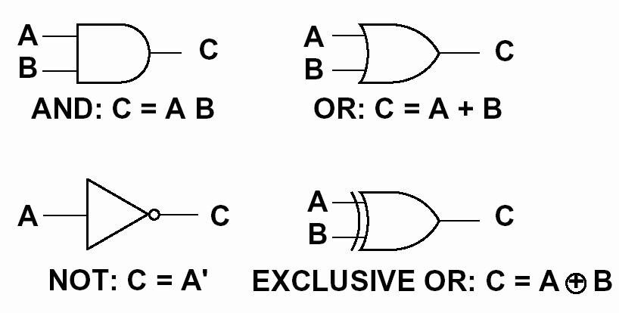
Multiplexers: 2-to-1 Multiplexer
„ Have number of data inputs, one or more select inputs, and one output
„ It passes the signal value on one of data inputs to the output
s
s w0

w0 0
f
w1 1 f

(a) Graphical symbol
w1

(c) Sum-of-products circuit

s f

0 w0
1 w1

f = s' w0

+ sw1

(b) Truth table

Multiplexers: 4-to-1 Multiplexer

s0
s1

w0 00
w1 01
w2 10 f
w3 11

s0
s1 s0 f
0
w
0 0 w0 s1
0 1 w1
1 0 w2 w

1 1 w3 1

f

(a) Graphic symbol
(b) Truth table
w2

w3

(c) Circuit

f = s1'
s0' w0
+ s1'
s0w1 +
s1s0' w2
+ s1s0w3

Multiplexers: Building Larger Mulitplexers

s0
s1

w0

s1
w3
s0

w0 0
w1 1

w2 0
w3 1
w4 s2
s3

w7

0 f

1
f w8

w11

(b) 16-to-1 using 4-to-1

(a) 4-to-1 using 2-to-1
w12

w15

Decoders: n-to-2n Decoder
„ Decode encoded information: n inputs, 2n outputs
„ If En = 1, only one output is asserted at a time
„ One-hot encoded output
„ m-bit binary code where exactly one bit is set to 1

n

inputs

w0 y0

wn – 1

2n
outputs
y0 y1 y2
...
= wn−1 '...w1 ' w0 ' En

= wn−1 '...w1 ' w0 En

= wn−1 '...w1w0 ' En

Enable En
y2n – 1

y2n −1

= wn−1

...w1w0 En

Decoders: 2-to-4 Decoder
En  1 | w1  0 | w0  0 | y0  1 | y1  0 | y2  0 | y3  0
1 | 0 | 1 | 0 | 1 | 0 | 0
1 | 1 | 0 | 0 | 0 | 1 | 0
1 | 1 | 1 | 0 | 0 | 0 | 1
0 | x | x | 0 | 0 | 0 | 0

w0
y0
w1

y1

(a) Truth table

y2

w0 y0
w1 y1 y3
y2
En y3 En

(b) Graphic symbol
(c) Logic circuit

Decoders: 3-to-8 Using 2-to-4

w0 w0 y0 y0
w1 w1 y1 y1
y2 y2
w
2
En y3 y3

En w0 y0 y4
w1 y1 y5
y2 y6
En y3 y7
Decoders: 4-to-16 Using 2-to-4

w0 w0 y0 y0
w1 w1 y1 y1
y2 y2
En y3 y3

w0 y0 y4
w1 y1 y5
y2 y6

w2 w0 y0
En y3 y7

w3 w1 y1
y2

En En y3
w0 y0 y8

w1 y1
y2
En y3
y9
y10
y11

w0 y0 w1 y1 y2
En y3
y12 y13 y14 y15

Encoders
„ Opposite of decoders
„ Encode given information into a more compact form
„ Binary encoders
„ 2n inputs into n-bit code
„ Exactly one of the input signals should have a value of 1,
and outputs present the binary number that identifies which input is
equal to 1
„ Use: reduce the number of bits
(transmitting and storing information)

w0
y0

2n
inputs y

n
outputs

w2n – 1
n – 1

Encoders: 4-to-2 Encoder

w3 w2 w1 w0

0 0 0 1
0 0 1 0
0 1 0 0
1 0 0 0
y1 y0
0
w
0 0 w
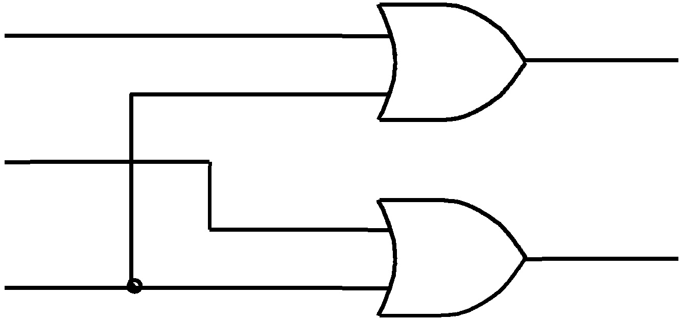

1
0 1 y0
1 0
1 1 w2

y1
3
w

(a) Truth table

(b) Circuit

Read-Only Memories
„ Store binary data
„ data can be read out whenever desired
„ cannot be changed under normal operating conditions
„ n input lines, m output lines =>
array of 2n m-bit words
„ Input lines serve as an address to select one of
2n words
„ Use ROM to implement logic functions?
„ n variables, m functions
Basic ROM Structure

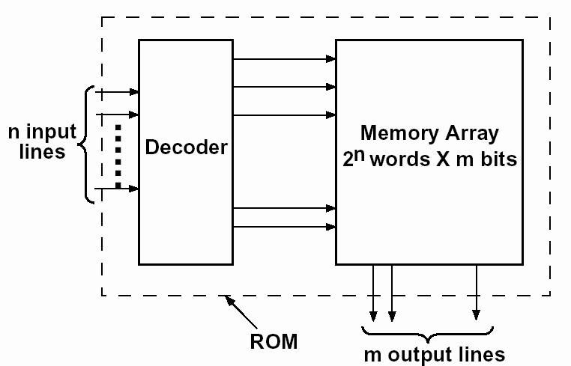
Sequential Networks
„ Have clock and state
„ Present state depends not only on the current input, but also on all previous inputs (history)
„ Future state depends on the current input and state
X = x1 x2... xn
Q = Q1 Q2... Qk
Z = z1 z2... zm
x1 z1
x2 Q z2

xn

Z ( t ) =

F ( X

( t ),

Q ( t ))
z Flip-flops are
m commonly used as
storage devices:

Q ( t + ) =
G ( X
( t ),
Q ( t ))
D-FF, JK-FF, T-FF

Clocked D Flip-Flop with Rising-edge Trigger

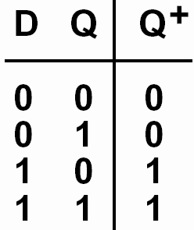

Next state

The next state in response to the rising edge of the clock is equal to the D input before the rising edge
Clocked JK Flip-Flop

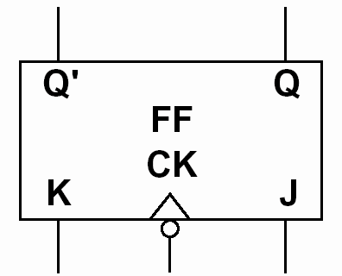
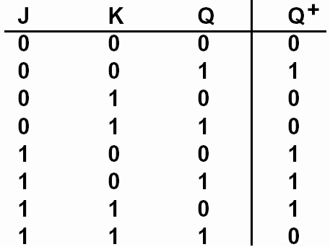

Next state
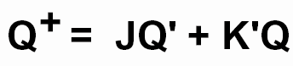

JK = 00 => no state change occurs
JK = 10 => the flip-flop is set to 1, independent of the current state
JK = 01 => the flip-flop is always reset to 0
JK = 11 => the flip-flop changes the state Q+ = Q’
Clocked JK Flip-Flop

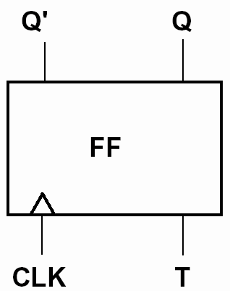

Next state
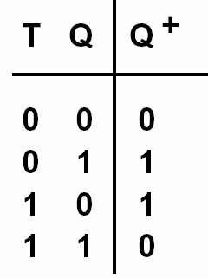

T = 1 => the flip-flop changes the state Q+ = Q’ T = 0 => no state change
S-R Latch

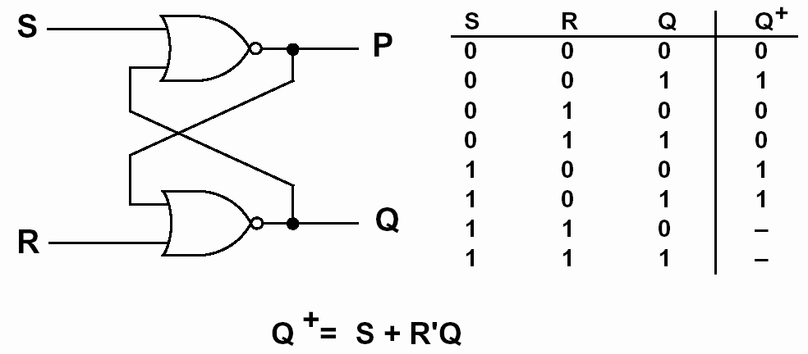
Transparent D Latch

